Thank you!
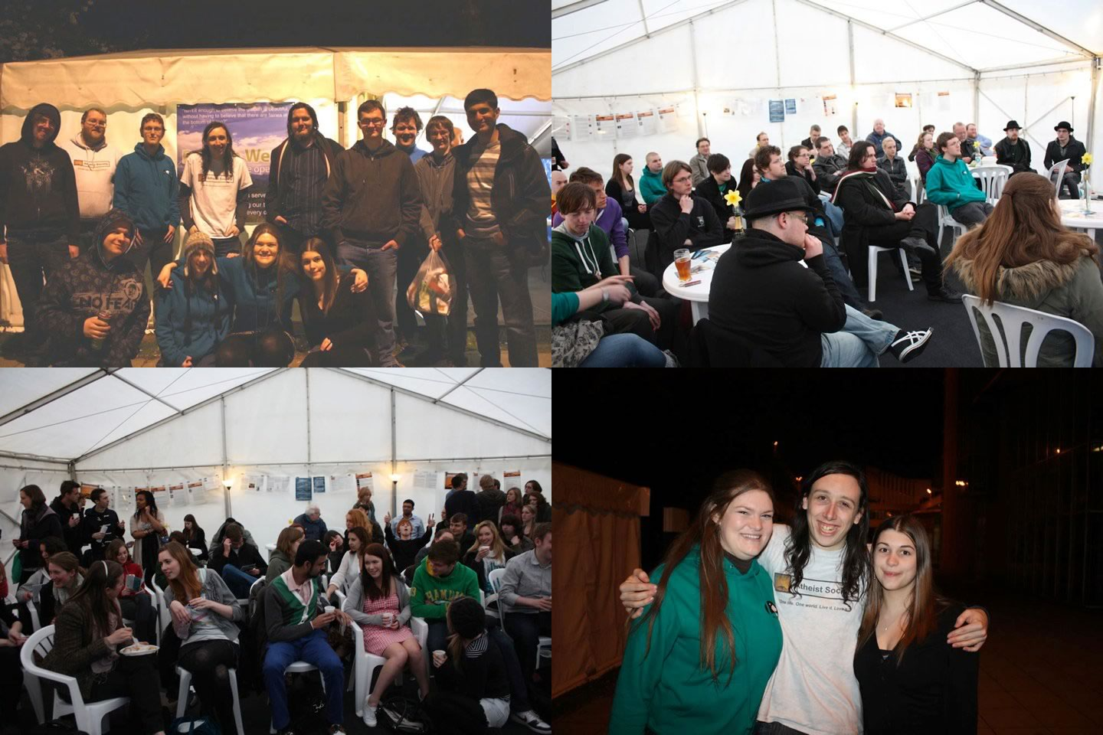
Thank you for making Reason Week 2010 a reality. Your support allowed us to put on an awareness week open more hours, with more events and seen by more people than any other similar event in the UK!
The week went incredibly well with us playing to a packed out marquee almost every night – no less than 67 people attended the debate with the Christian Union, so many people that we simply didn’t know what to do with them all.
The society also saw up to a dozen new members join the society as well as many others saying they would check out our events or volunteered to get involved with our projects.
If you haven’t seen it already, you may want to check out the official photo gallery of the event on our website at:
http://leeds.atheistsoc.org/photos
Best regards,

Jonni, Chris & the members of Leeds Atheist Society

