‘Good morning Mr. Magpie’
In the western world magpies are often seen as portents of evil or bad luck and many different superstitions have arose around them including ‘One for sorrow, two for joy...’, if a magpie lands on your roof then your house wont collapse and the excruciatingly embarrassing ritual of saluting and greeting every lone magpie that a person sees in order to ward off bad luck.
The latter seems to have originally came about from an old belief that Satan would often visit the world disguised as a magpie in order to cause harm and by greeting him you could show that you knew who he was and his power over you was broken. The origin of the rhyme on the other hand does not have a clear origin but it has been ascribed to many other birds (e.g. Crows) and has been altered greatly over generations which shows that it is highly unlikely to contain any truth within it. Another reason for distrusting magpies is the belief that they were the only bird not to sing at the death of Christ or that they did not wear full mourning to his crucifixion
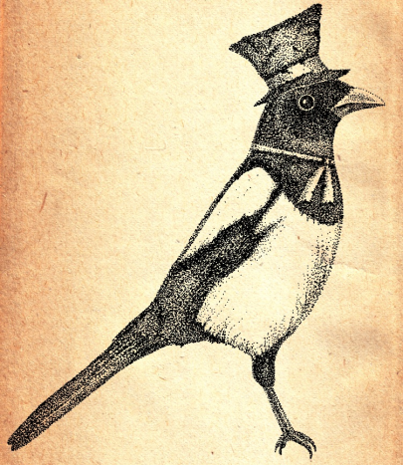
Due to the soaring numbers of magpies in the UK over the past few decades this superstition will probably die out by itself over time as the sighting of magpies increases and it is no longer practical to keep it up anymore but in the meantime it seems pointless to let the sight of an incredibly common lone magpie ruin your day or make you look like an idiot in public.

